NI Multisim 2015

INTRODUCTION.

Create a Folder (in “H” rename etc.). This will be used when you do FILE; Save as.

Double click the MULTISIM Icon; when opening it may ask for a directory path; select the new folder.

A drawing sheet (white with grid dots) will appear, and the library is already loaded.

(Top left quarter shown for clarity)

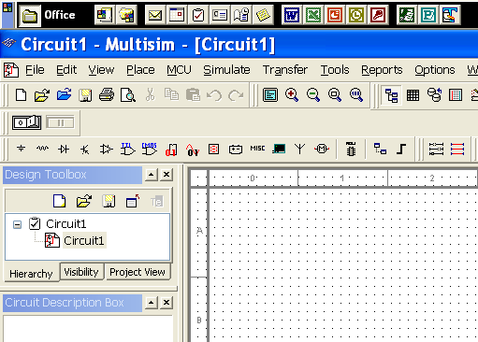

FILE;save as (NEW NAMEand put into YOUR folder). This can be done either before or after working on a circuit.

ALSO; when using Multisim AND Instruction sheet; simply open and close them (temporarily) by LEFT click on the label along the bottom of the screen (to the right of START). This is much faster and easier than completely closing one system to see the other.

LIBRARIES

The library is divided into sections;

- PLACE SOURCE; DC-Power and Signal Sources (ALSO GND terminal)

- PLACE BASIC; Passive components (R, C, L etc.)

- Diodes (and Zeners).

- Transistors. BJT NPN and BJT PNP etc.

- Op-Amps. Etc. etc.

- CMOS ( Logic gates for digital ).

Select and place components on drawing sheet. You may select R and C values from the list provided, OR use the same one repeatedly, then change values.

RIGHT click a component to make changes (orientation etc.and Properties (LEFT double click also) )

eg. 90deg rotation (orientation), select PROPERTIES to enter value;
eg 4.7k, 3.3u etc. (NOTE, do NOT enter 4k7 or 3u3).

WIRING (red)

To wire up components there is no need to select a command; simply position the cursor at a pin; LEFT click and procede to next pin.

(NOTE, for 3 or more components attached to the same NET, click pin on third component, then click onto NET; “NOT” the pin.) .

Double click NET and change label ( input, output etc.) and select SHOW. This allows you to select the correct waveforms in simulation.

SIMULATION

MENU; Simulate; Analyses. Then choose;

- DC operating point; (Multimeter)

When viewing the simulation dialogue, click on OUTPUT, then select from list on LEFT; click ADD and it will appear on the RIGHT. Now click SIMULATE.

- Transient Analysis; (Scope )

- AC analysis; ( BODE plot). Etc.

The signal source should have suitable numbers for:
Transient Analysis ( Voltage (Pk) and Frequency (F) ) and
AC Analysis ( AC Analysis Magnitude ).

To change frequency range or time interval (for clearer graph), CLOSE the simulation then select in MENU again; BUT enter some new numbers. This may be repeated several times to produce clear graphs.

ALSO, the VIEW menu is useful for modifying graphs. Eg. Reverse Colours, Show Cursors etc.

There is no need to save individual graphs, as the numbers will be saved with the schematic.

Transient Analysis; Start time (TSTART) and End time (TSTOP).

Eg. 0 and 50ms (entered as 50e-3); or 100e-6 and 200e-6.

Also increase Minimum number of time points for better resolution (say 1000)

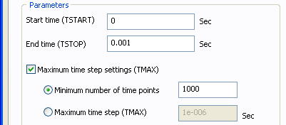

For AC Analysis; enter frequency range; Sweep type (mostly Decade) etc.

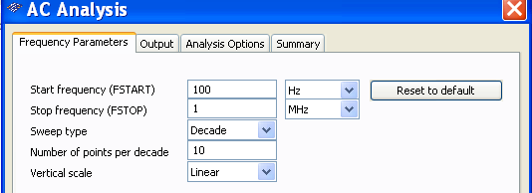

The following single transistor circuit can be used as a practical example, exploring the construction of a schematic, and running analogue simulations.
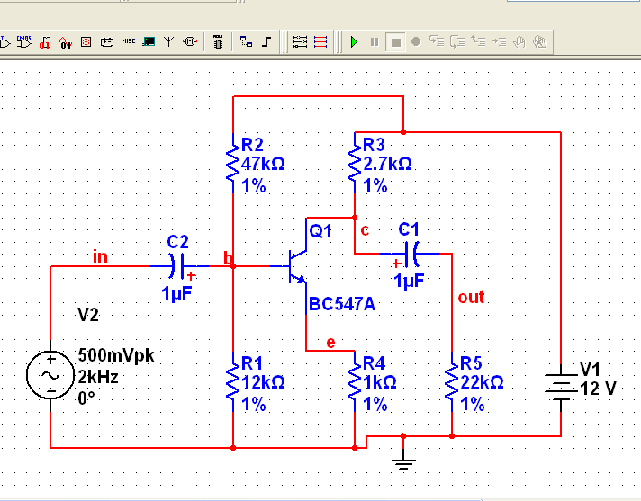

For Digital circuits

The SOURCES library contains a “CLOCK_VOLTAGE” which is preset to 0 to 5V; 50% duty cycle. The frequency can be easily changed.

Eg. 4 Bit counter; position FOUR “CLOCK_VOLTAGE” side by side;

MSB ( left ) set to 1kHz; Next 2kHz; Next 4kHz; Next 8kHz.

A “BUS” is several (16 for 16 Bit ) wires running parallel.

Menu PLACE; BUS click and draw thick red line.

R-clk. PROPERTIES; BUS LINES; B1 Add, B2 Add B3 Add etc.

Connecting to BUS;
From PIN to “Spot” closest to BUS_LINE; then select B1 or B2 or B3 etc.

Transient Analysis is normally the only simulation required.

The Logic gates in the library seem to operate without the need for an additional DC voltage. (May be a problem when it comes to PCB layout!!).

When viewing several logic signals (0, 5V) they appear overlapped and difficult to see properly. To change this select “EDIT; properties; traces; auto separate; OK.”
OR, display as DIGITAL signals before running.
